

Ban Koh Klang community is a community surrounded by rivers and mangrove forests. People live a simple life by doing fishing and handicrafts.
08.00 a.m. Pick you up from hotel by VIP van
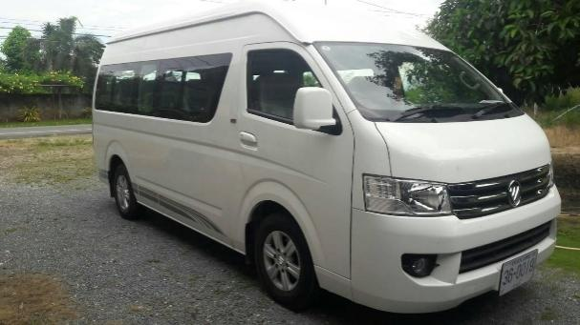
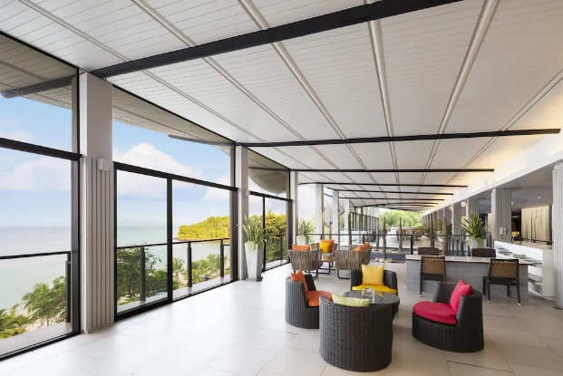

08.30 a.m. Head to Wat Panurach to make merit by offering alms to monks and pray
for good fortune. After that, walk around the temple, see the forest garden,
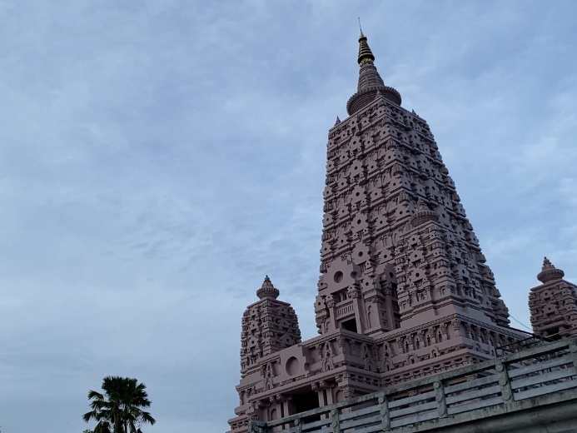
a shady place for you to relax your mind.
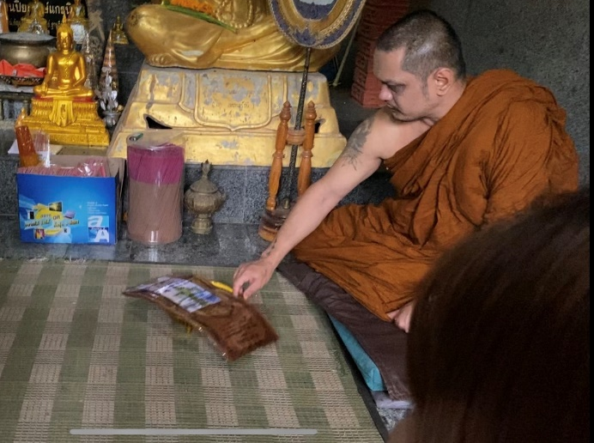
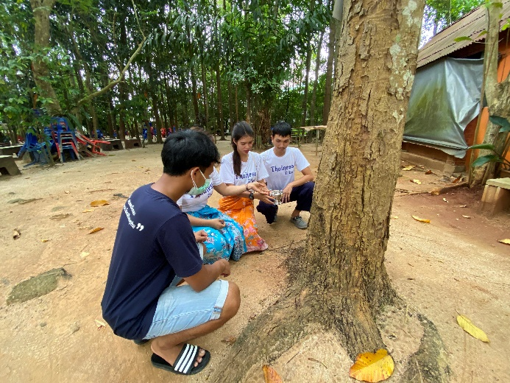
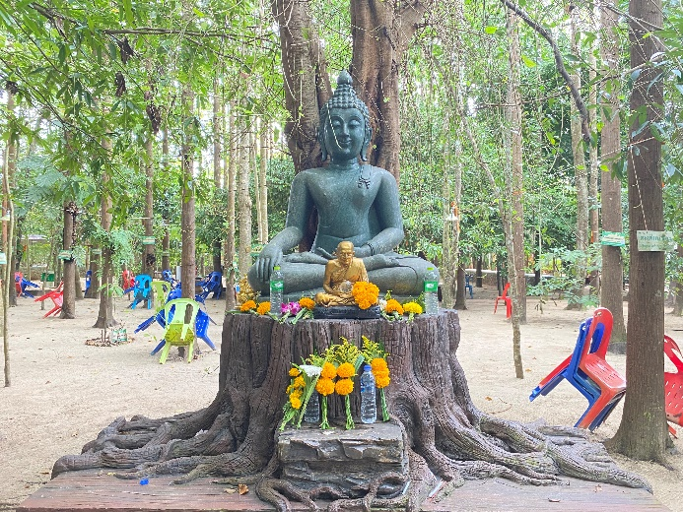
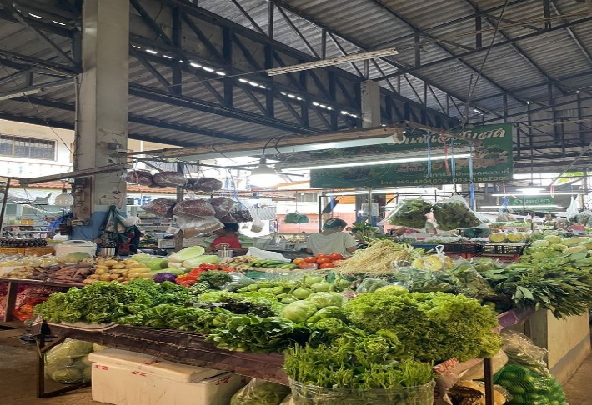
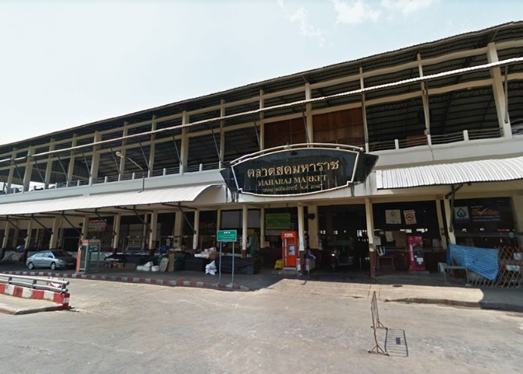
*** For our Muslim guests, the tour offers a visit to Maharaj Fresh Market, the main local market of Krabi Province. This experience allows you to explore the local way of life, observe daily activities of the community, and taste authentic local cuisine in a culturally respectful and Muslim-friendly environment.

09.00 a.m. Take you to the historical wall of Krabi town Built on the occasion of the 141st anniversary of the establishment of the city of Krabi. To tell the story of the history of Krabi from the past, present and future, the wall is divided into a total of 28 compartments, each with a low-relief sculpture.

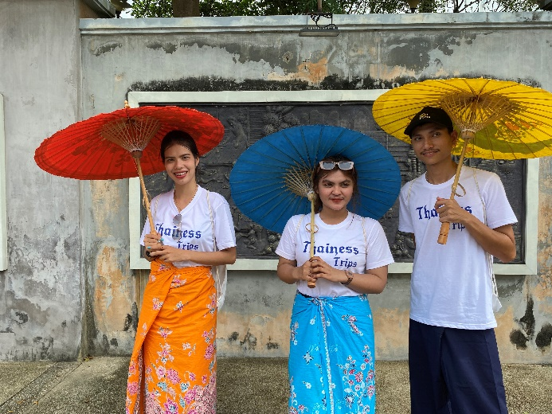
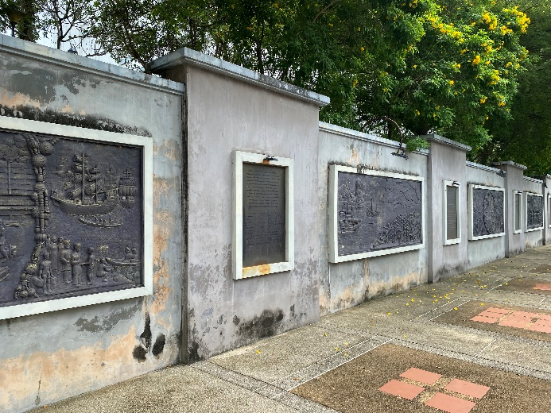
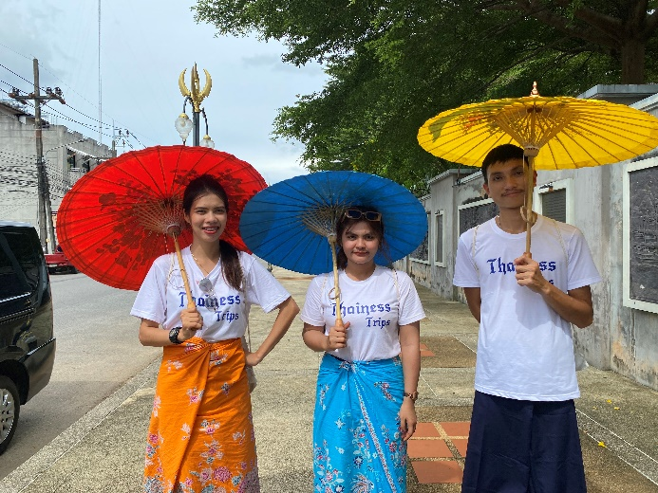
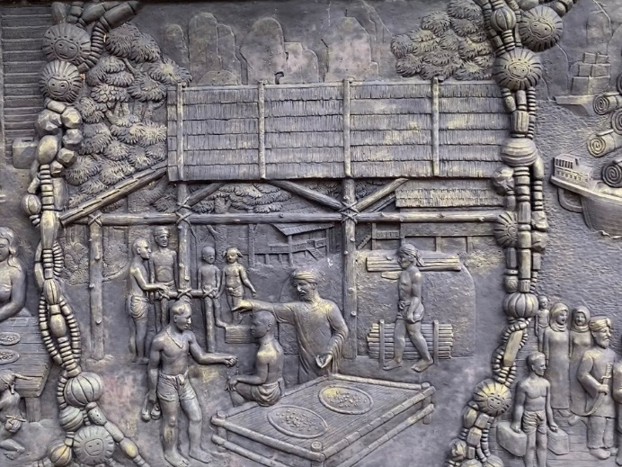
09.45 a.m. This point is a good viewpoint of Krabi town because you can see Khao Khanap Nam, two mountains standing prominently on the Krabi River and are also symbols of Krabi town. Near the black crab sculpture, there is a "Nok Ok Monument" or eagle, a local bird here. The reason for building the monument in the shape of a black crab and a nok ok is because these two are animals that represent the prosperity of Krabi town.
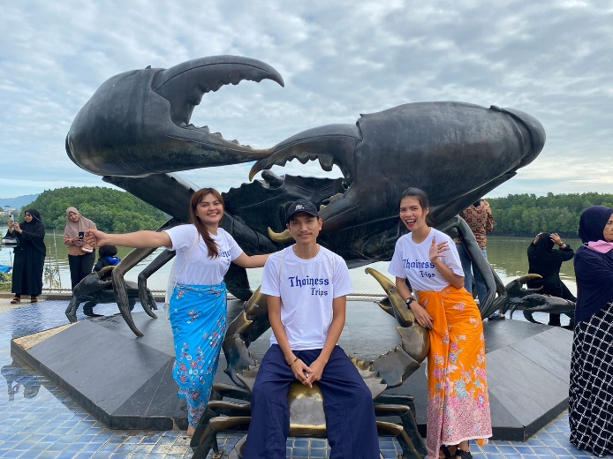
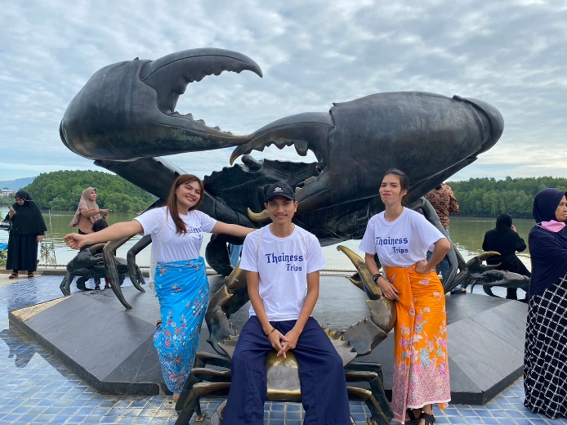
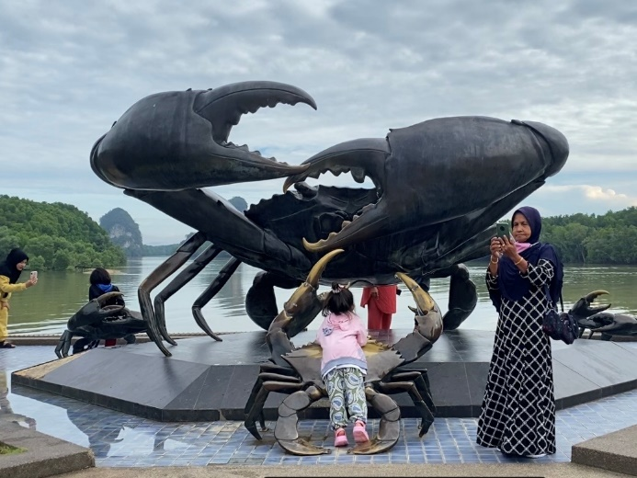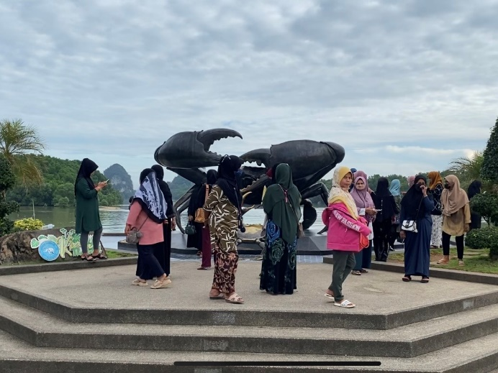

10.00 a.m. After that, we will take you on a long-tailed boat to Khao Khanap Nam, which is the highlight of Krabi Province. There is also a legend about Khao Khanap Nam that says there was a princess who was wanted by the Naga and the Giant. The Naga transformed into a human to fight the Giant over the princess until they both died, causing their bodies to become these two rocky mountains..
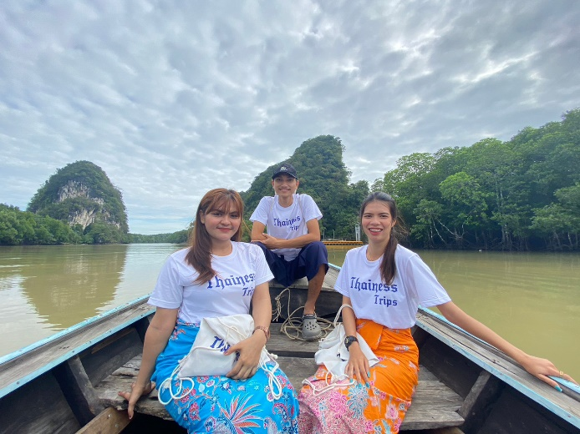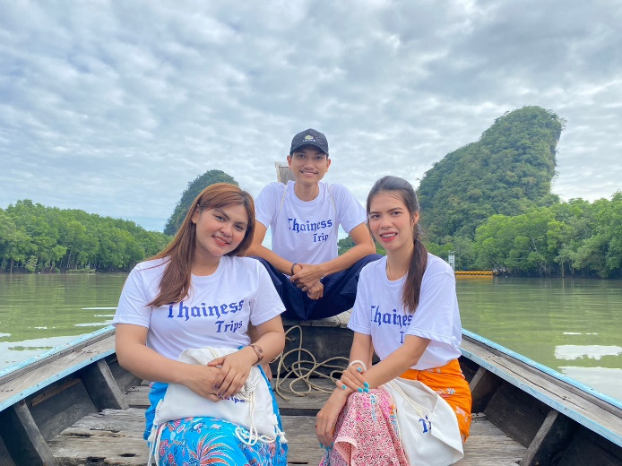
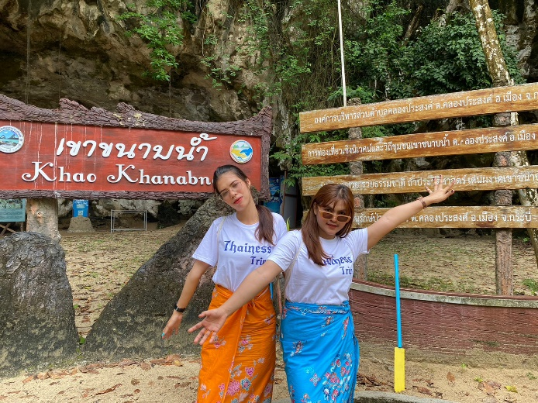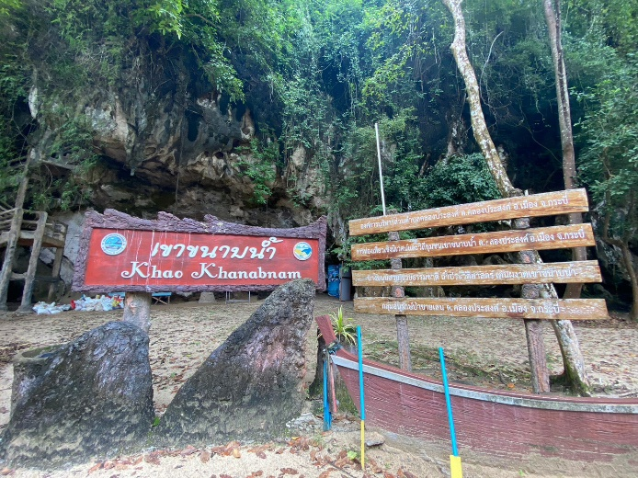
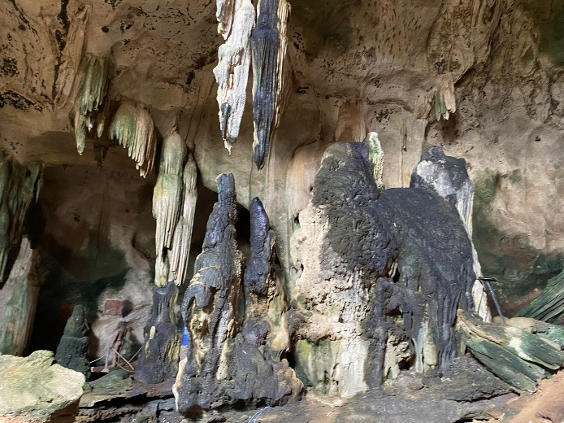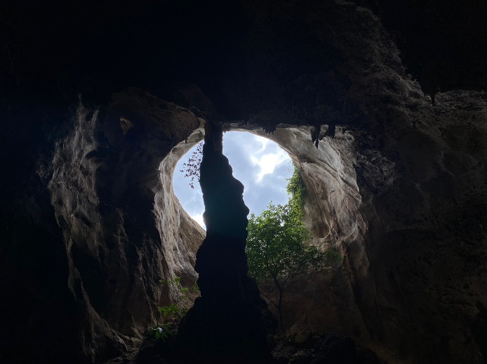
Inside the cave of Khao Khanap Nam, there are beautiful stalactites and stalagmites. Ancient human skeletons were once discovered in this cave. It is assumed that these may be the skeletons of a group of people who migrated here and settled down, who probably died in the flood.
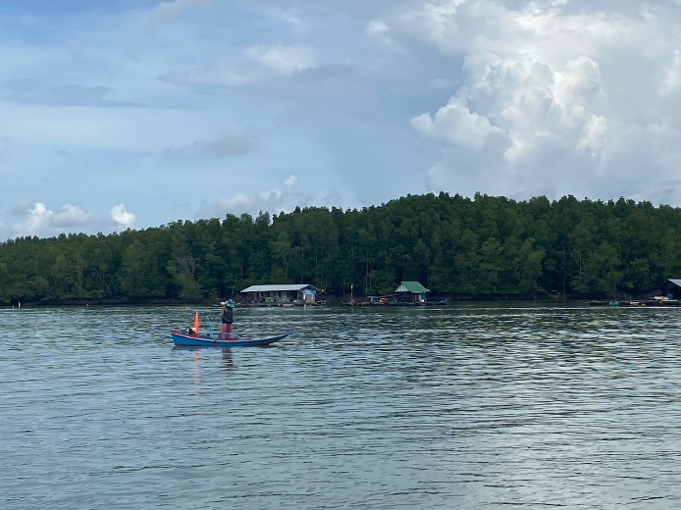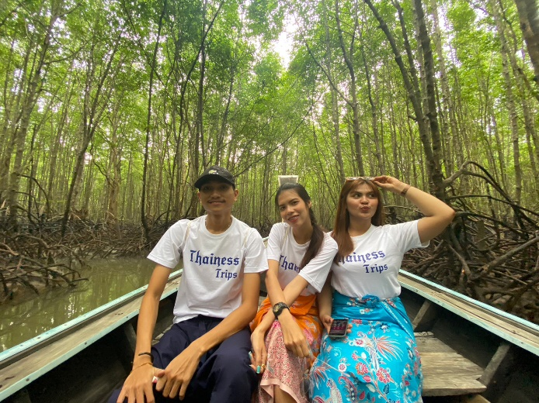

11.20 a.m. And we’ll have lunch at Kanab nam View Seafood restaurant. It’s a popular restaurant in Koh Klang
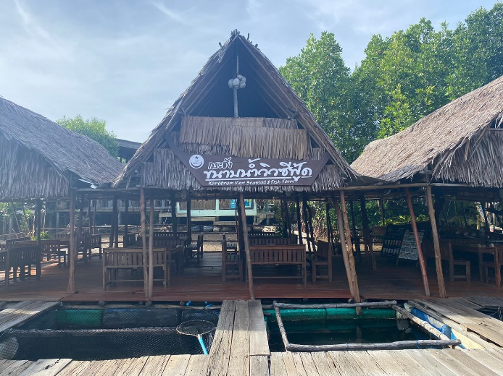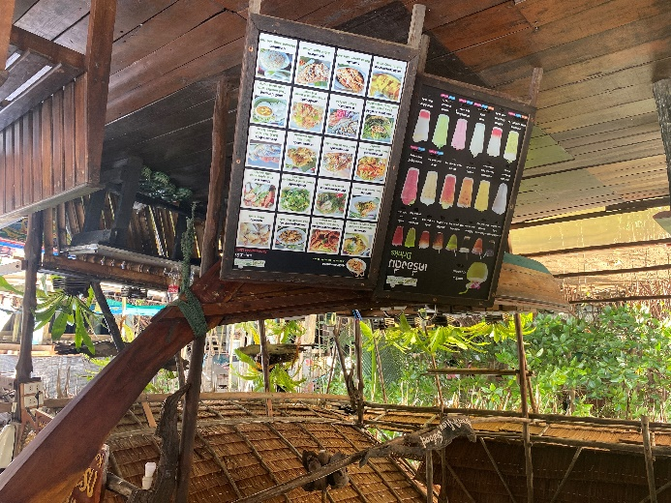
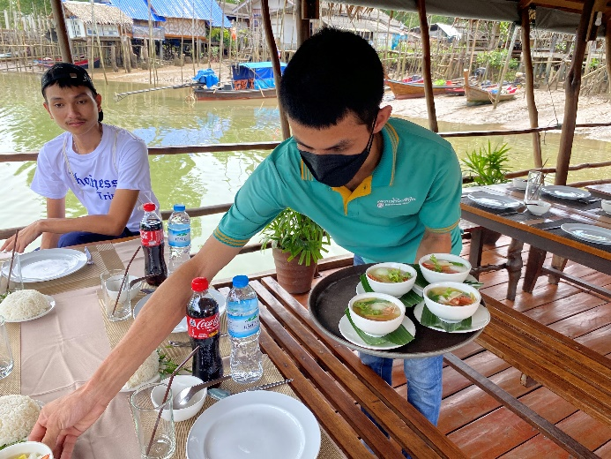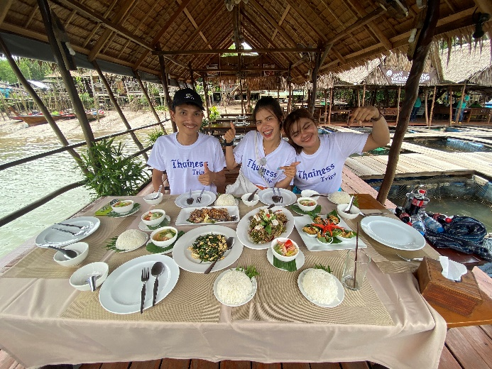
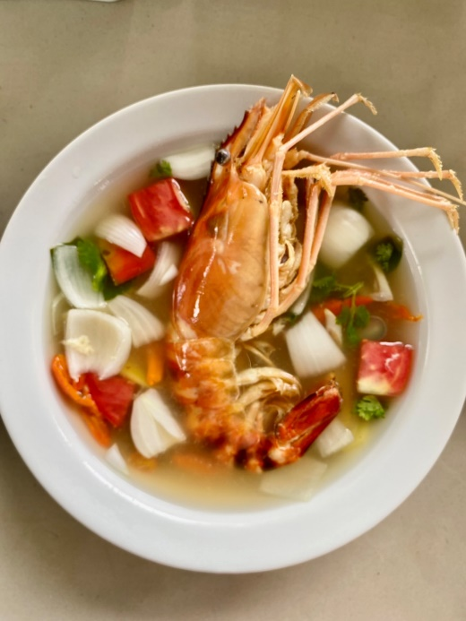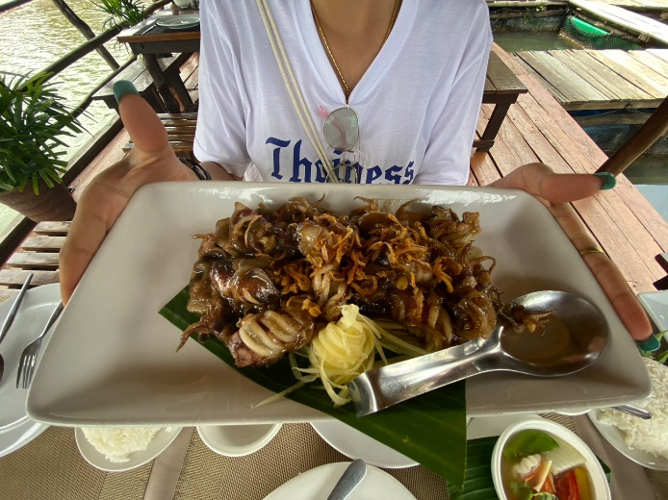

12.20 a.m. After lunch take you to see the traditional rice milling using human labor by sidecar.
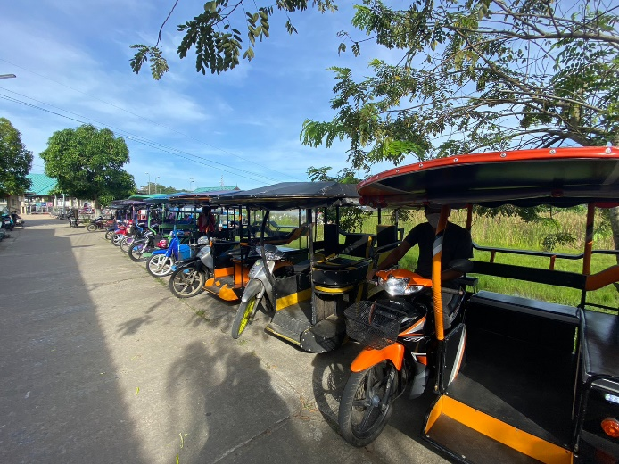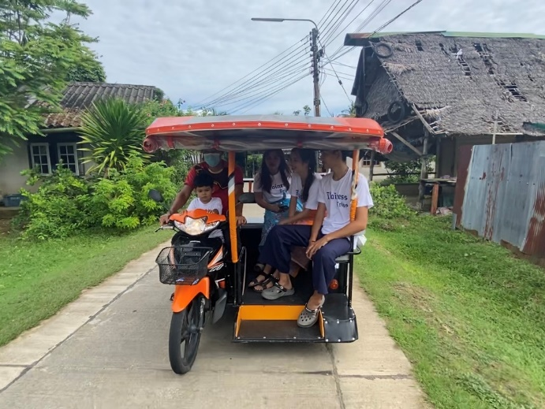
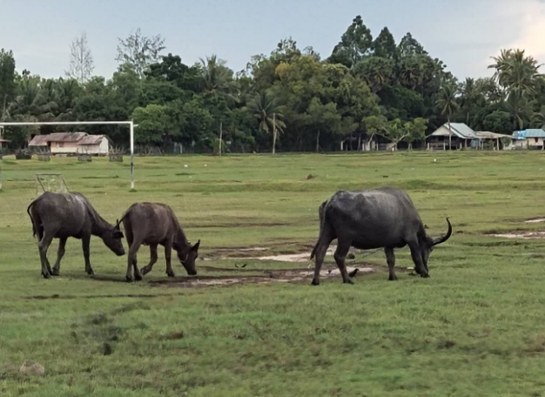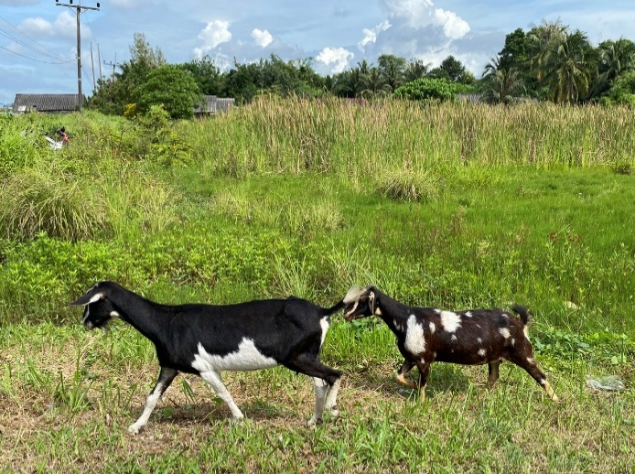
This will show the process of changing from paddy to milled rice.
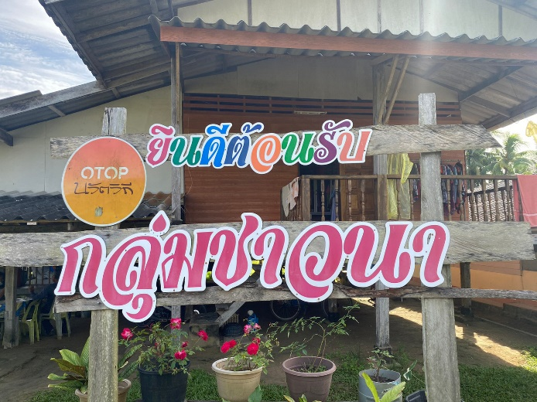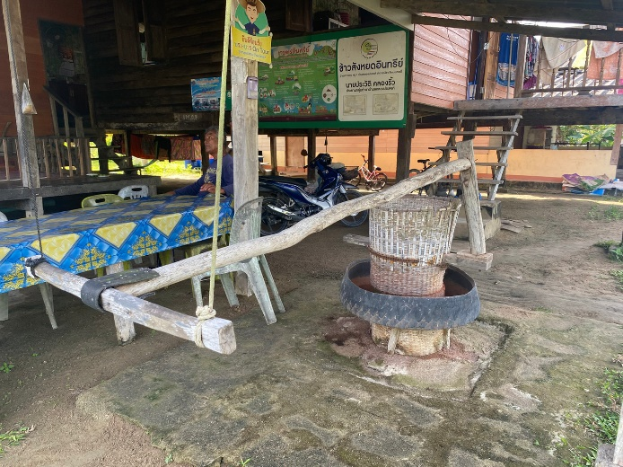
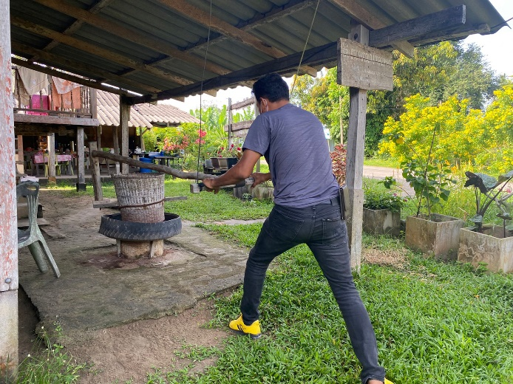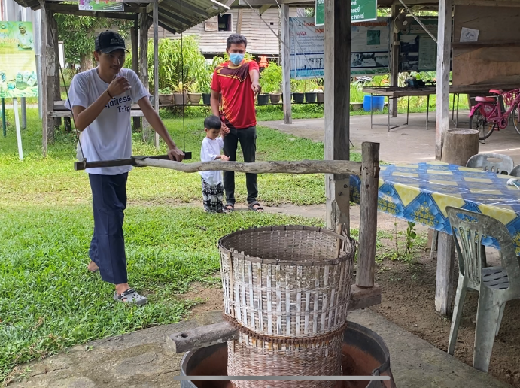

12.40 a.m. Products from coconut shells is a local handicraft which is the processing of coconut shells to have a higher value can be sold as a souvenir. There are many products made from coconut shells, such as keychains, earrings, hair clips, bracelets, and fridge magnet .
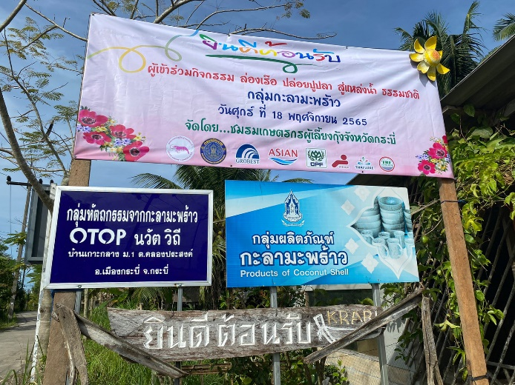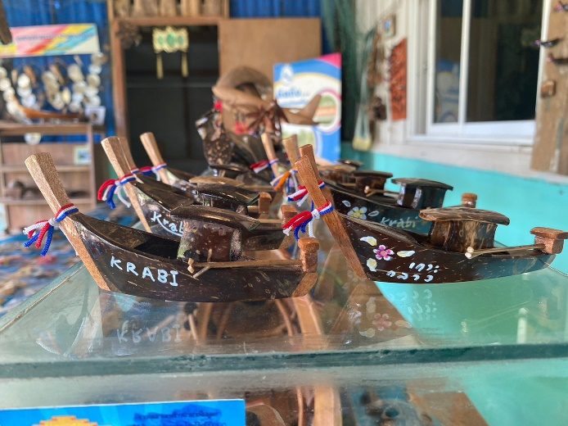
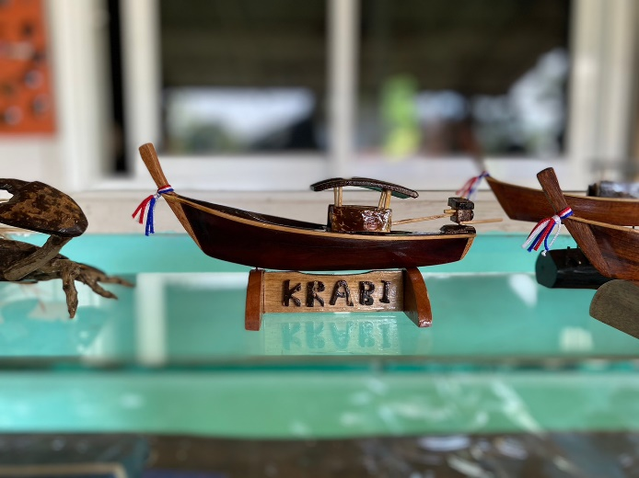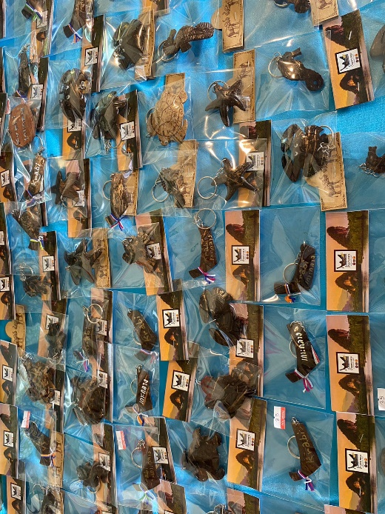
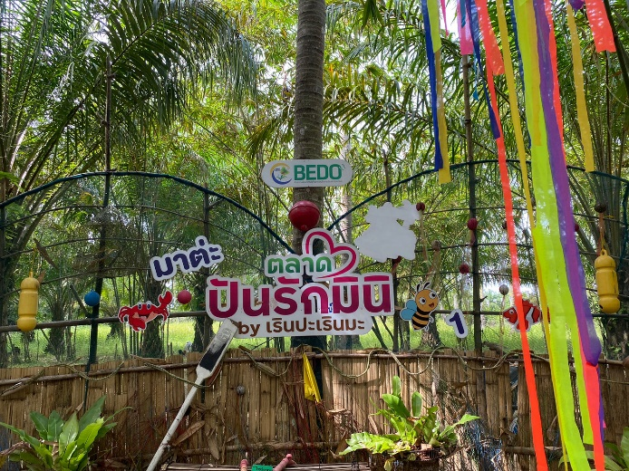
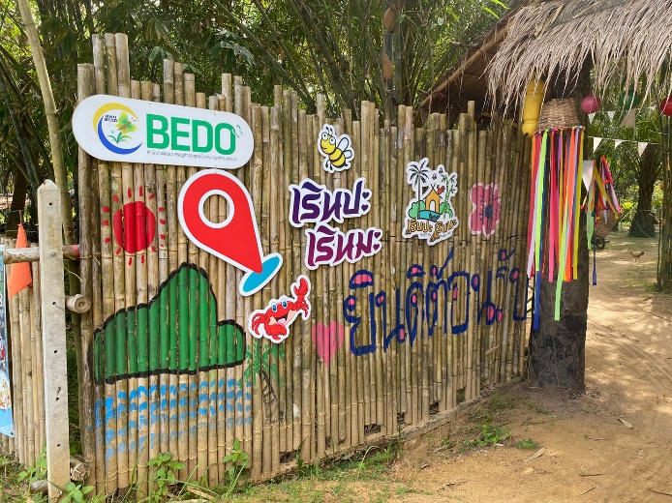
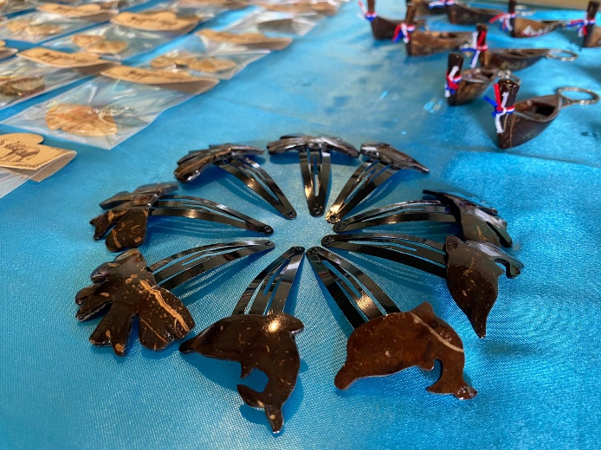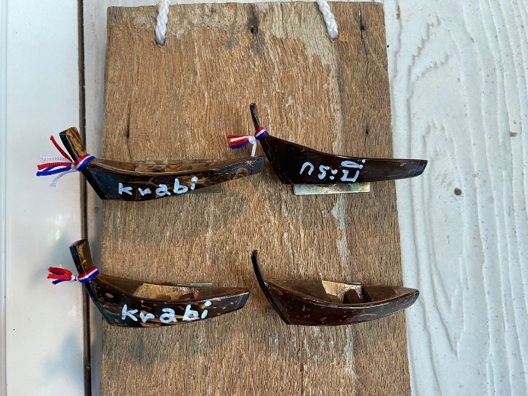

01.10 p.m. See products made from coconut shells, local handicrafts that transform coconut shells to increase their value. Model of long-tailed boats, which is a continuation of the way of life of the people of Koh Klang in the past who liked to use long-tailed boats for fishing and traveling. Currently, the occupation of building long-tailed boats has decreased because their use has decreased and the original long-tailed boats are harder to find. Villagers therefore joined together to make a model of long-tailed boats. Tourists will learn about the history of the boats that are a symbol of Krabi Province. The model of long-tailed boats from Koh Klang has been developed into a 4-star OTOP product.
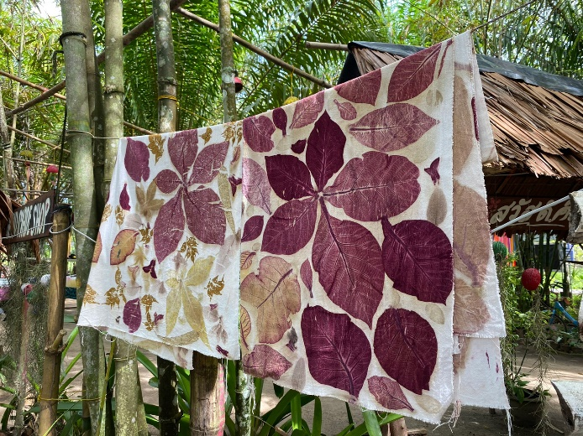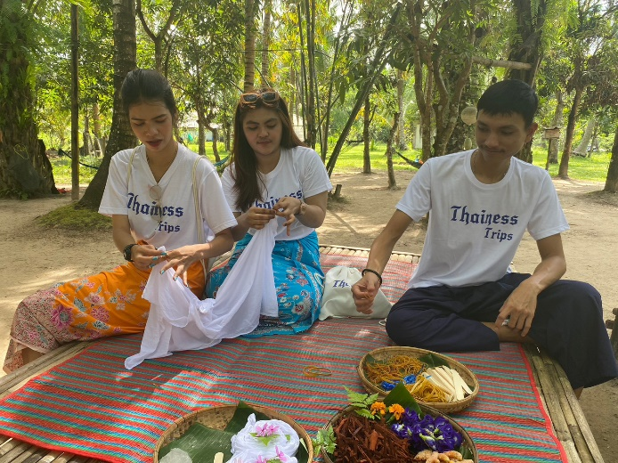
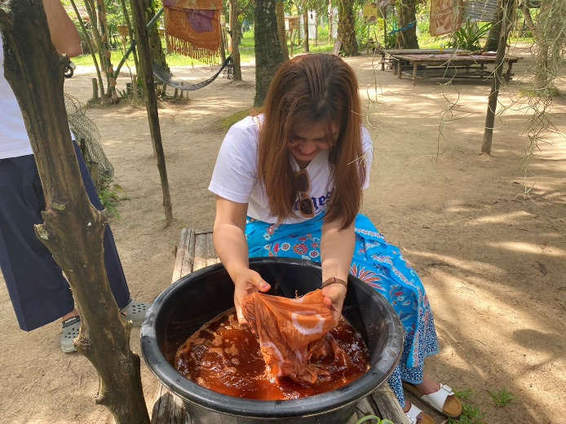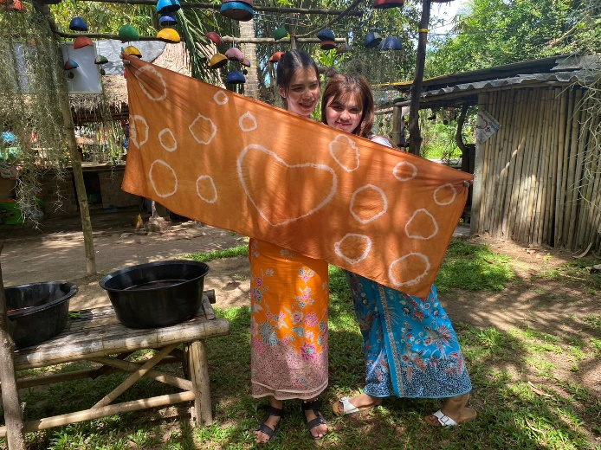
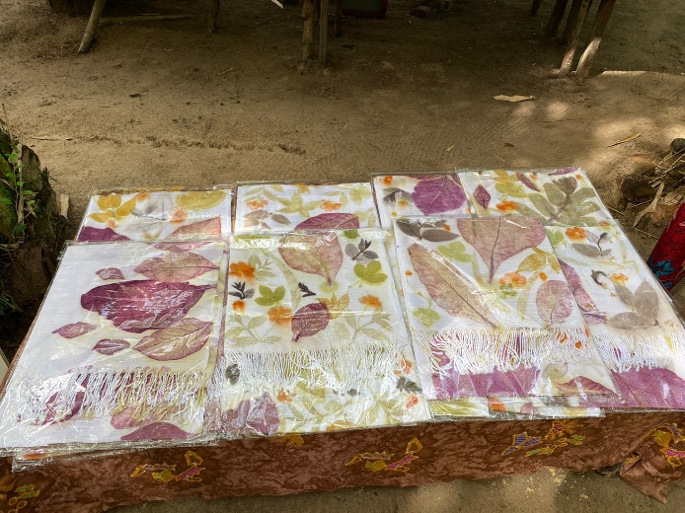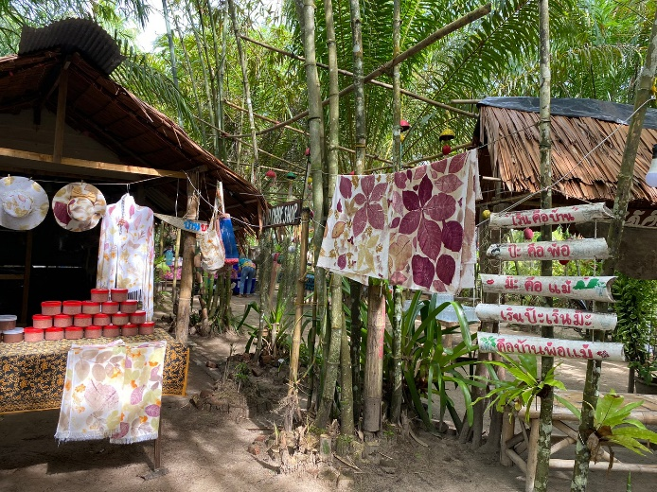
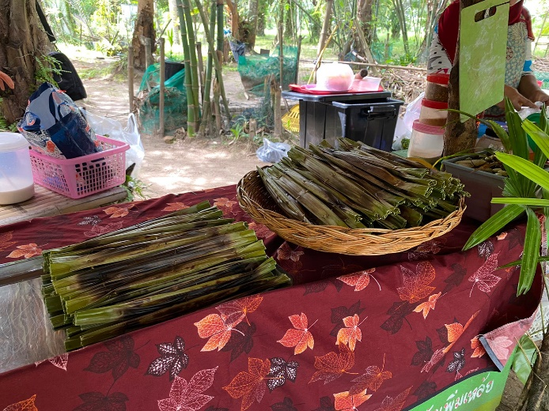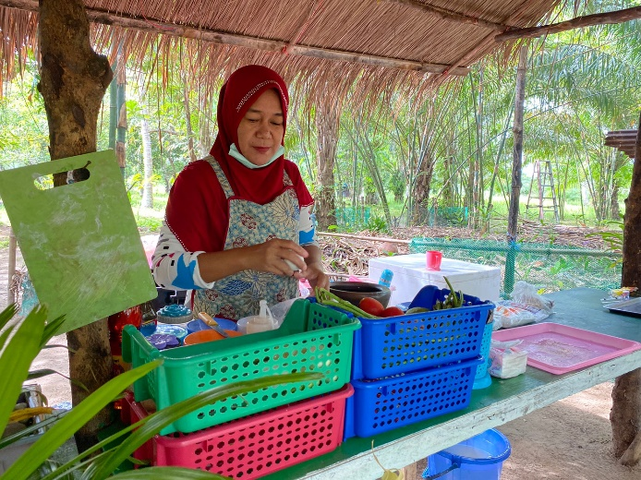
02.30 p.m. Going back to Thara park pier by Hua Thong boat and Transfer back to your hotel.
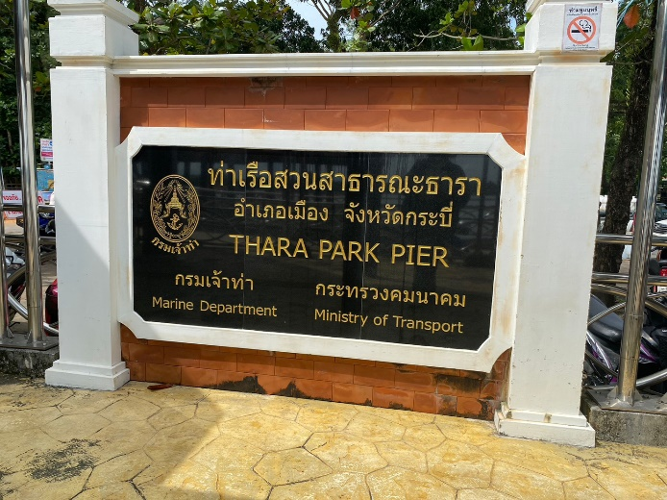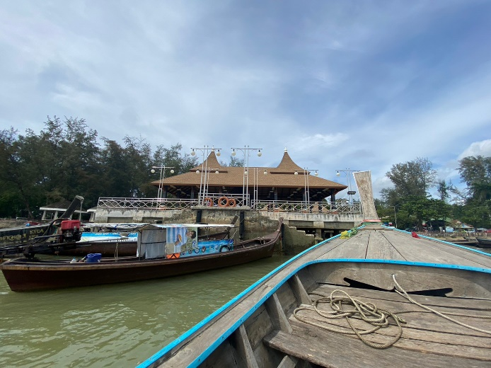
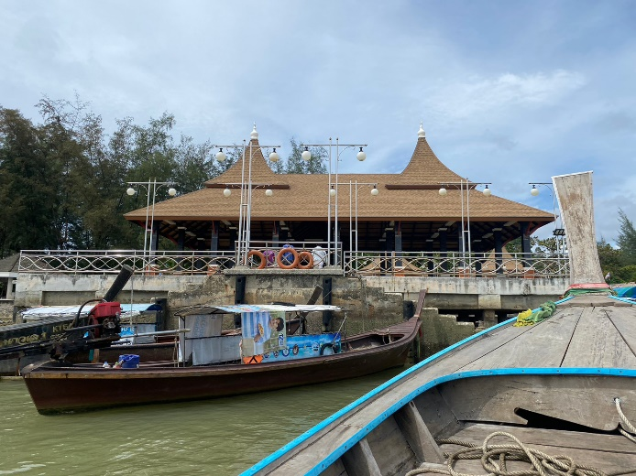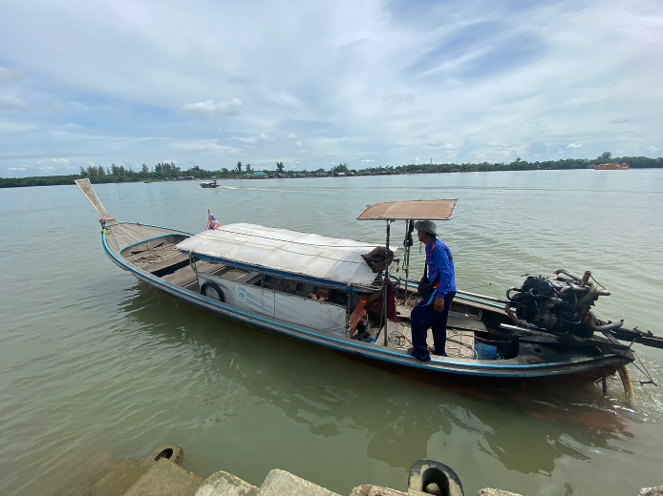
Service Rate (Start from 1 PAX)
No. | Price for  Adult | Price for  4 – 10 years old
1 PAX | 7,900 | 6,500
2 PAX | 4,990 | 3,600
3 PAX | 3,900 | 3,200
4 PAX | 3,400 | 2,800
5 PAX | 3,200 | 2,350
6 PAX | 3,000 | 2,200
7 PAX | 2,800 | 2,100
8 PAX | 2,700 | 2,000
Under 3 years | FREE

Program Include  ✔ Service Transfer all Trip  ✔ Lunch  ✔ The yellow robe for the monk  ✔ Tie-dye  ✔ Batik / fisherman pants  ✔ eco-friendly fabric bag  ✔ Accident insurance coverage is subject to the terms and conditions of the insurance policy. | Program Exclude  ✘ Tips for Guide and Driver  ✘ Airplane Ticket
*** The tour program is subject to change as appropriate depending on weather conditions ***

